Name: ____________________________ Grade 3/
EXERCISE
- Reorder the sentences
- your/ is/ what/ name/?  ……………………………………… | - ’s/ Lan/ it/ ‘s/ hat/.  …………………………………………
- are/ my/ these/ eyes/.  ………………………………………... | - grandpa/ a/ is/ my/ doctor/.  …………………………………………
- the/ is/ on/ the/ slide/ ball/.  ………………………………………… | - are/ how/ you/?  …………………………………………
- this/ your/ is/ pen/ ?  ………………………………………….. | - old/ you/ how/ are/?  …………………………………………

II.Circle the odd-one- out.Write.
1.socks | shorts | kitchen | coat | kitchen
2.dress | sheep | goat | tiger | ______________
3.bedroom | dining room | kitchen | tree | _____________
4.mom | pilot | cousin | brother | _____________
5.doctor | teacher | pool | nurse | _____________
6.seesaw | house | slide | pool | _____________
7.coat | chair | window | door | _____________
8.shoes | sheep | pants | T-shirt | _____________
9.his | her | he | my | _____________
10. I | my | he | she | _____________
11.car | bike | toy | doll | _____________
II.Write the words in the correct box:
living room pants doctor dad grandma student kitchen socks brother bedroom firefighter bathroom T-shirt shorts
dress farmer coat sister teacher cousin nurse
dining room pilot grandpa mom

Clothes | Rooms | Family | Jobs
III.Order the words:
1.is / her / This /dress. This is her dress.
2.these/ Are/shorts/ his? _______________________________________?
3.are/ pants/ These/ her. ________________________________________
4.this / Is / coat/ your ? _______________________________________ ?
5.is/This/ living room/ the. ___ ___________________________________
6.are/ Where/ dad/ mom/ and ? _______________________________________ ?
7.Rosy/ Where / is ? ________________________________________?
8.is/ She / kitchen/ the / in . ________________________________________
9.are/ They/ living room/ in/ the. ________________________________________
10.is/ This /bedroom/ my . ________________________________________
11.she/ Is / the / in /bedroom? ____________________________________
IV.Write:
living room dining room bedroom bathroom kitchen

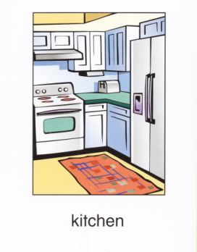 | This is a _____________________
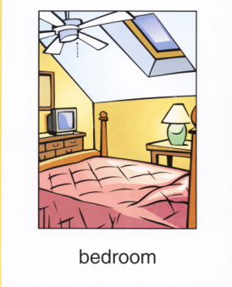 | This is a _____________________
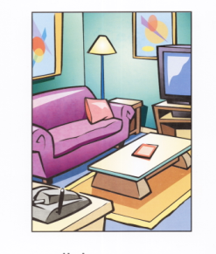 | This is a _____________________
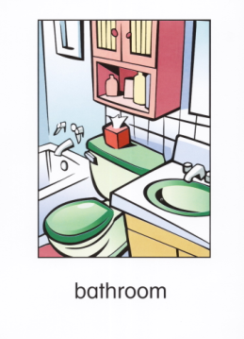 | This is a _____________________
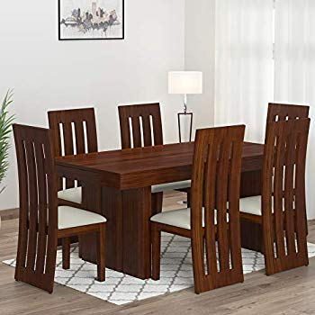 | This is a _____________________
V. Complete the sentences.
is are isn’t aren’t

1.________ Rosy in the kitchen ? Yes, she ________.
2 . ________ Mom and Dad in the living room? Yes, they________.
3 . _______ Kate upstairs ? No, she________.
4 . ________ Bob in the bathroom ? Yes, he ________.
5. ________Grandpa and Grandma in the living room? No, they________.
6. ________he a farmer ? Yes, he ________ .
7. ________they downstairs ? No,they ________
8. ________ this a living room ?No, it ________.
9. ________ these her shorts ? Yes, they ________.
10. ________she in the bathroom ? Yes, she ________
VI.Match:
1.Where is the kitchen?  2. Is he in the bedroom?  3.Where are Dad and Billy?  4.Are mom and dad in the bedroom?  5.What’s this?  6.What color is it?  7.What color are these shorts?  8.Is this his T- shirt?  9.Who’s this?  10.How old are you? | a. He’s Billy.  b. Yes, it is.  c. I’m ten.  d. It’s downstairs.  e. No, he isn’t. He’s in the bathroom.  f. It’s a book.  g. They are in the dining room.  H .It’s blue.  I. Yes, they are.  J. They are black. | 1- d  2-  3-  4-  5-  6-  7-  8-  9-  10-

VII. Look and write:
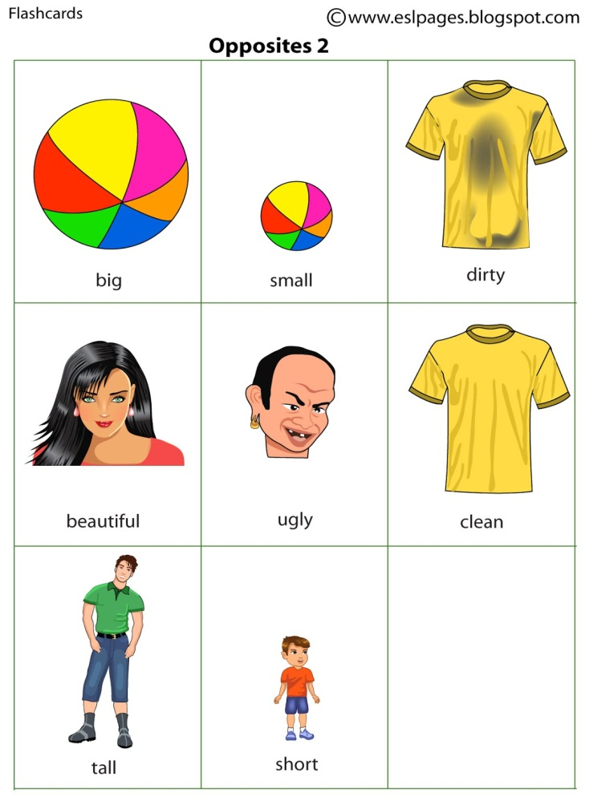  _____________ | 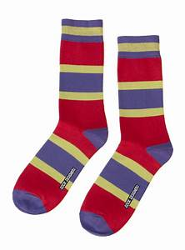  _____________ | 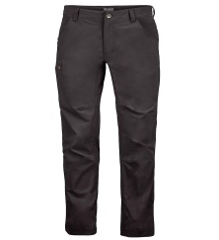  _____________ | 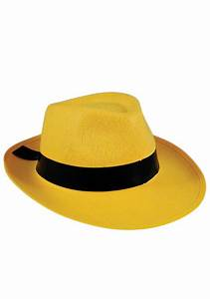  _____________
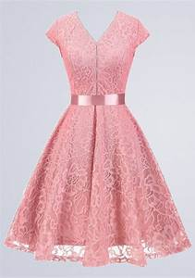  _____________ | 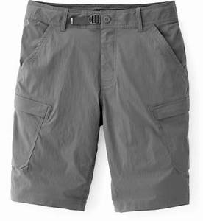_____________ |   _____________ | 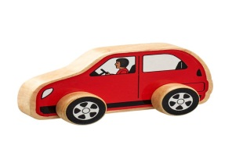  _____________
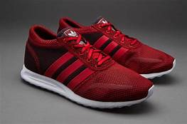  _____________ | 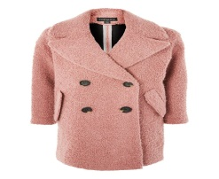  ____________ | 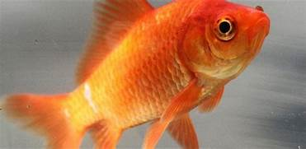  _____________ | 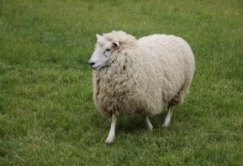  _____________
  _____________ | 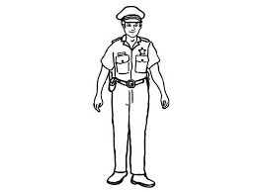  _____________ |   _____________ | 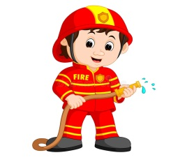  _____________
  _____________ |   _____________ | 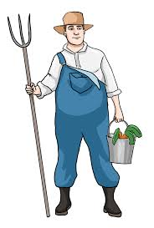  _____________ | 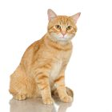  _____________
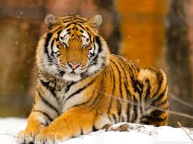  _____________ |   _____________ | 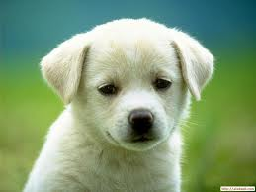  _____________ | 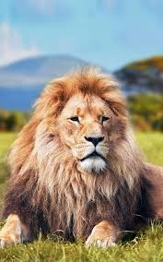  _____________
VIII.Complete the sentence:
He is a___________ | He is a ___________
These are his ______________ | This is a ____________________
She is a ______________________ | He is a ___________
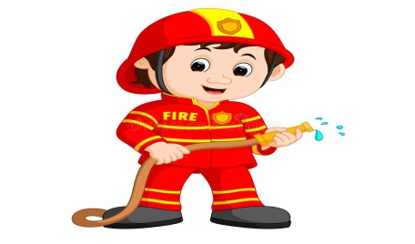  He is a ___________ | 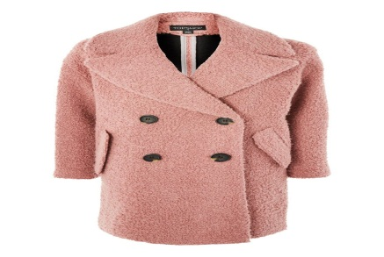  This is a ____________________
He is a ___________ | These are his ______________
This is a ____________________ | This is a ____________________
These are his ______________ | These are her ______________

IX.Answer the question:

  1. What’s this ?  It’s a ________________ |   2. What’s this ?  It’s a ____________________
  3. Who’s this ?  He’s my ___________ | 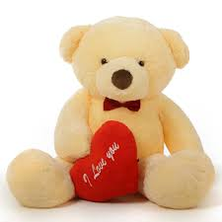  4.What’s this ?  It’s a ____________________
  5. What’s this ?  It’s an __________________ | 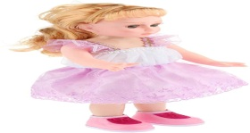  6.What’s your favotite toy?  It’s a _________________
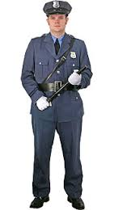  7.Is he a pilot ?  No, _______________.    9.Is he a pilot ?  Yes, _____________.  11.What’s this ?  It’s a _______________.  13.What’s this ?  It’s a ________________.    15.Is this a train?  No, _________________  17. Is this a kite?  No, _______________    19.Is she a nurse ?  Yes, _________________  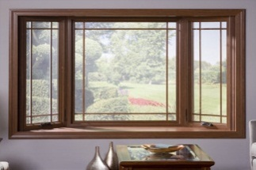  21.What’s this?  It’s a _____________ | 8.Is he a farmer ?  Yes, ___________________  10.Is he a doctor ?  No, ___________________.    12.Is she a teacher ?  Yes, ____________________  14.Is this a dog ?  No, _________________  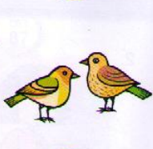  16.What’s this?  It’s a ________________  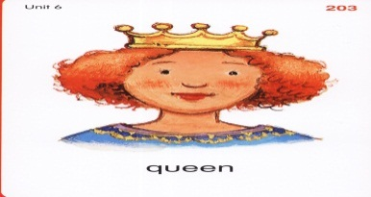  18.Who’s this?  She is a _______________  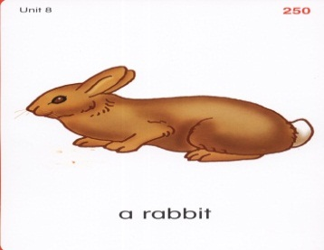  20.What’s this?  It’s a ______________  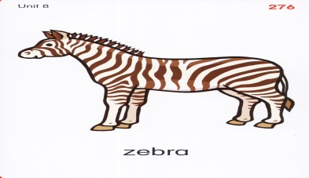  22. What’s this?  It’s a ______________

